**SOFTWARE REQUIREMENTS SPECIFICATION DOCUMENT FOR THE WORLD CUP ANALYZER**

**SUBMITTED BY GROUP-6 IN PARTIAL FULFILLMENT OF REQUIREMENTS FOR THE RECESS TERM 2018**

.

Contents

1. Introduction 1

1.1 Purpose 1

1.2 Document Conventions 1

1.3 Intended Audience and Reading Suggestions 1

1.4 Product Scope 2

1.5 References 2

2. Overall Description 2

2.1 Product Perspective 2

2.2 Product Functions 2

2.3 User Classes and Characteristics 3

2.4 Operating Environment 3

2.5 Design and Implementation Constraints 3

2.6 User Documentation 4

2.7 Assumptions and Dependencies 4

3. External Interface Requirements 4

3.1 User Interfaces 4

3.2 Hardware Interfaces 5

3.3 Software Interfaces 6

3.4 Communications Interfaces 6

4. System Features 6

4.1 Team Analysis 6

4.2 Team Seeding 7

4.3 World Cup factor evaluation 7

5. Other Nonfunctional Requirements 8

5.1 Performance Requirements 8

5.2 Safety Requirements 8

5.3 Security Requirements 8

5.4 Software Quality Attributes 8

APPENDIX A: ANALYSIS MODELS 9

# Introduction

## Purpose

The purpose of this document is to give a detailed description of the requirements and functionalities of the **World Cup Analyzer**, a prediction and visualization model that will be able to analyze the rankings of the men’s national football teams by FIFA to be able to predict their performance in the World Cup as well as consider the seeding of the teams that qualify for the World Cup into groups.

## Document Conventions

This document follows the IEEE format and is typed in Times New Roman with a font size of 12, save for headings, and a line spacing of 1.5.

## Intended Audience and Reading Suggestions

This document is intended for;

Developers

This product will be hosted on Github and will, in the future, be open to other developers to contribute to it if they are interested. The project will be open source therefore anyone will be able to access this code and use it the way they wish.

Users

The users of this product will be able to analyze the world cup tournament and predict the winner of the tournament. They will also be able to visualize the data from the FIFA World rankings to get information such as which team has been on top for the longest. Section 2.6, User Documentation is an important section for users.

## Product Scope

**World Cup Analyzer** is an application program that uses FIFA World rankings from August 1993 to June 2018 to make a prediction of who may win the FIFA World Cup tournament. It takes in the FIFA rankings dataset and analyzes the data to produce a visualization of the data. A prediction of how far each team in the tournament will go is made by using its average position in the rankings. In essence, a prediction of who may eventually win the tournament will be made.

## References

Concept Paper

This document proposes the idea of analyzing the FIFA world rankings to determine their effectiveness in predicting the eventual result of the tournament.

Author: Group-6

Version number: 2.0

Date: 24th June, 2018

Location: ###

# Overall Description

## Product Perspective

**World Cup Analyzer** is a software program that determines how far a team goes in the FIFA World Cup tournament. It thus predicts the team that may win the tournament. Visualization of various statistics is also done by the tool to avail information to the user.

## Product Functions

Users of the **World Cup Analyzer** receive the following features:

* Team performance analysis: Users will be able to enter a valid team whose performance they wish to analyze, and they’ll be able to see how far the team will go in the tournament.
* World Cup seeding: Users will be able to use the system to seed teams in pots and see the different arrangements of teams in groups.
* World Cup factor evaluation: An evaluation will be made on the factors that determine the rank of a team. This is a low priority function.

## User Classes and Characteristics

This product is intended for the following classes of people:

* All classes of users: World Cup Analyzer is a simple piece of software and thus it will be very easy to use for anyone with basic computer literacy skills.
* Open source developers: As the project will be hosted on Github, open source developers will be able to contribute to the project and extend the capabilities of the World Cup Analyzer software.
* Contributors: Anyone interested in helping Group-6 to better the World Cup Analyzer software will contribute to the project.

## Operating Environment

World Cup Analyzerwill be able to run in any operating system. Using a browser application, users will be able to access the software and use its features.

## Design and Implementation Constraints

The challenges involved in developing this product include exhausting all the insights involved in analyzing how far a team may go in a FIFA World Cup tournament. Moreover, writing a predictive model that considers all the important factors that determine how far a team goes in the tournament without the benefit of other datasets such as tournament game results data is a challenge.

All the functions of the World Cup Analyzer will solely be derived from the FIFA Rankings dataset.

## User Documentation

Along with the software product, a user manual will be written to help people understand how the developed system works. It will be written for nontechnical individuals and the level of content or terminology will differ considerably from, for example Design Documentation, which is more detailed and complex. The user manual would follow common user documentation styles capturing purpose and scope of the product along with key system features and operations; step-by-step instructions for using the system including conventions, quick references, tips for errors and malfunctions; pointers to reference documents; and glossary of terms.

## Assumptions and Dependencies

We assume that the group and opponents in the group in which a team has been seeded doesn’t affect the final position of the team in the tournament.

We do not take into consideration the fact that FIFA puts the host country of the World Cup in the first pot as this factor is always subject to change.

# External Interface Requirements

## User Interfaces

The Predictions page;

Here, users will be prompted to enter a name of a team in the text box and a prediction will be made for them as to how far a team can proceed throughout the tournament.

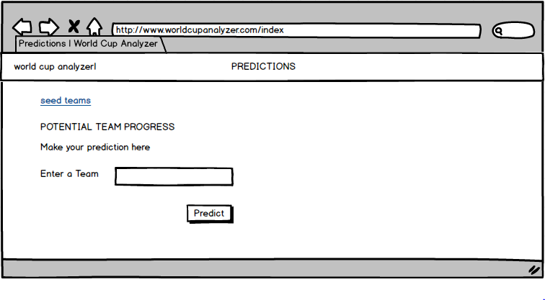

The Seeding Teams page;

Here, the users will check boxes alongside the teams and upon clicking the seed button, a visualization of a bar graph showing the pots of the teams will be displayed to them.

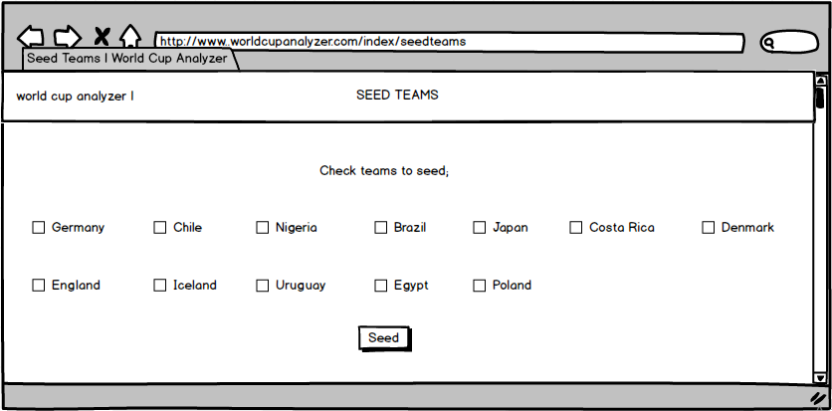

## Hardware Interfaces

The World Cup analyzer will be supported on mobile as well as desktop computing devices.

## Software Interfaces

Most of the functionality of the World Cup analyzer is run in an R program using R Studio, v.3.5. The World Cup analyzer will also be accessible on GitHub, an online platform for a Distributed Version Control System called Git, via which developers can make further contribution to the program by having an application called Git Bash on their local machines in order to help them mirror the remote Git server on which the source files of the program are.

The program can be run on both Linux and Windows Operating Systems by developers wishing to make improvements to it.

## Communications Interfaces

World Cup analyzer will be open-sourced on GitHub where developers can access its source code to make contributions to it. The program will be accessible online via any web browser on a website for users.

# System Features

The World Cup Analyzer too will be able to perform analysis on the event of the world cup tournament in various ways;

## Team Analysis

4.1.1 Description and Priority

The system will be able to predict the performance of any team that is a member nation of FIFA at the world cup tournament event in terms of how far a team can advance in the tournament. The service is a high priority for the system.

4.1.2 Stimulus/Response Sequences

The system will allow users to enter a valid team they wish to analyze and the system will predict how far that selected team can advance in the world cup finals

4.1.3 Functional Requirements

REQ-1: The system should take a team as input first to predict its performance.

REQ-2: They system should then be able to to calculate the average ranking position of the team for the past four years

REQ-3: The average rank should be used by the system to predict the performance of a specified team

## Team Seeding

4.2.1 Description and Priority.

The system will be able to provide a service of seeding FIFA teams into pots. This feature is of high priority.

4.2.2 Stimulus/Response Sequences.

The system will allow users to enter a set of valid teams they wish to analyze and the system will seed the set of teams in pots using a potting algorithm.

4.2.3 Functional Requirements

REQ-1: The system should be able take a set of teams as input.

REQ-2: The system should be able to seed selected teams in to different pots using the FIFA world rankings.

## World Cup factor evaluation

4.3.1 Description and Priority.

The feature will enable users to evaluate how the factors that are used to rank FIFA teams are important and how much they are related to the ranking of the national men’s teams. This feature is of low priority.

4.3.2 Stimulus/Response Sequences.

The feature will be able to determine the correlation between the factors are used to rank the teams and the rank.

4.3.3 Functional Requirements.

REQ-1: The system should be able to establish a correlation between each factor that is used to ranking of teams.

# Other Nonfunctional Requirements

## Performance Requirements

The World Cup Analyzer software will be accessed online via Github and will be able to work on Windows, Mac OS, Ubuntu and Linux devices. It will also be accessible via a website and this is designed simply enough for a user to enter their team and get an analysis on it by just clicking submit. The World Cup Analyzer website is available to our Github repository and in this way will always have our latest updates to it.

## Safety Requirements

The World Cup Analyzer repository is accessible by anyone and therefore it will be easy for anyone to identify malware and be assured that the software is genuine.

## Security Requirements

The World Cup Analyzer website does not require a login and therefore does not store any information about the user. The user does not have to worry about privacy or security.

## Software Quality Attributes

It is advised that the World Cup Analyzer is used only for **predicting** and this may defer from actual results of the game.

Otherwise, it is accessible and very basic in terms of user manipulation. All a user must do is enter their team of choice into the simple form on the website.

# APPENDIX A: ANALYSIS MODELS

CONTEXT DIAGRAM FOR THE WORLD CUP ANALYZER



USE CASE DIAGRAM FOR PREDICTING PERFOMANCE OF A TEAM AND SEEDING WORLD CUP TEAMS

